Objective

The objective of this test is to ensure that Application Support Team receives notification for job failures in production (including batch job failures/abends).

Procedure

- Ensure that the application support team members received MIR3 email notifications.
- Ensure that the application support team received notifications from Operations Support Staff (OSS) for triaged batch job failures/abends, when required.
- Ensure that job failures are addressed according to standards.

Results/Observations

E.3.1 – Application Support Team members received MIR3 email notifications.

Internal Audit (IA) obtained evidence showing that the application support team members receive email notification due to a failure or abend from Padmalatha Ajit, Senior Manager, Application Development, on May 20th, 2021 (SDA Job Scheduling Doc). IA reviewed the document and observed that the control administrator sends a job failure report email to the Application support team and batchteam. In the report, the job name, action to be performed for the job failure and reason for failure is included in the body of email.

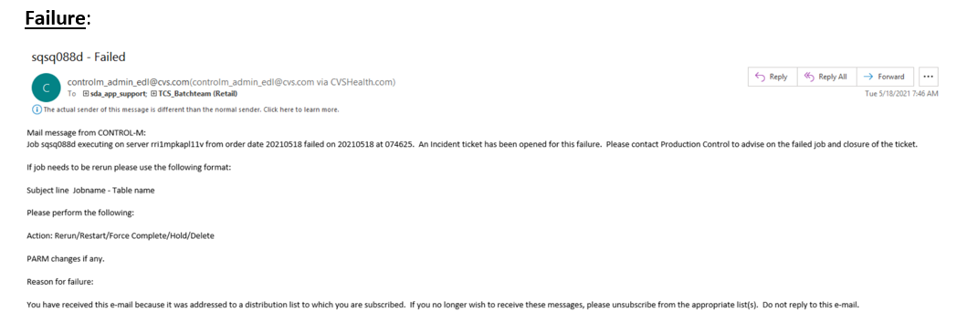
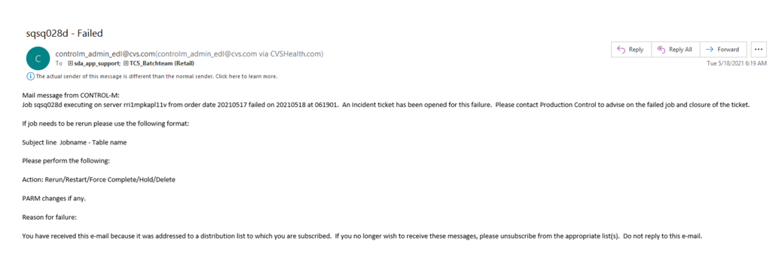

In addition, IA also received evidence showing that the application support team member receives a MIR3 alert with a request to either accept or reject notifying other users.

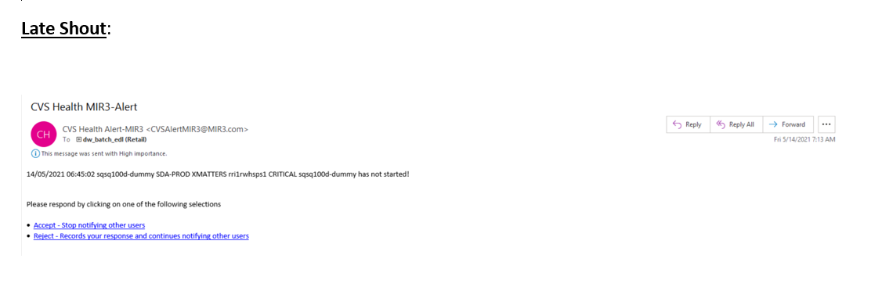As such, IA concludes that the Application Support Team members receive MIR3 email notifications. No action items or exceptions were noted.

E.3.2 – Application Support Team received notifications from Operations Support Staff (OSS) for triaged batch job failures/abends, when required.

Internal Audit (IA) obtained evidence showing that the application support team receives notifications from Operations Support Staff (OSS) for triaged batch job failures/abends, when required from Padmalatha Ajit, Senior Manager, Application Development, on May 20th, 2021 (SDA Job Scheduling Doc). IA reviewed the document and observed that the Operations support Staff (OSS) sends our a job failure email report to the application support team detailing reason why the job failed, a data log of the failure script and likewise includes next steps to be taken for further action on said failure.

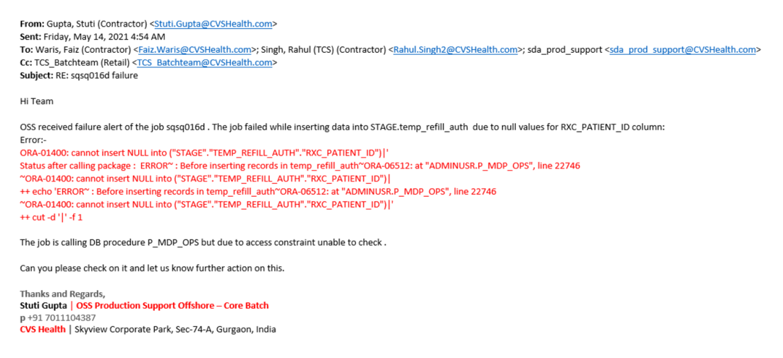

As such, IA concludes that the Application Support Team received notification from Operations Support Staff (OSS) for triaged batch job Failures/Abends, when required. No action items or expectations were noted.

E.3.3 – Job failures are addressed according to standards

Internal Audit (IA) obtained evidence showing that job failures are addressed according to Standards from Padmalatha Ajit, Senior Manager, Application Development, on May 20th, 2021 (SDA Job Scheduling Doc). On May 25th 2021, IA also received two follow up email thread from Harmesh Kumar, Onshore OSS Batch, detailing a conversation with appropriate personnel responsible for addressing job failures (Job Scheduling Notification Email 1)(Job Scheduling Notification Email 2). In the conversation, the job failure was defined, and a remediation plan was detailed to resolve the failure. Following this, the OSS support offshore personnel began working to resolve the job failure and likewise successfully resolved the job failure per established standards.

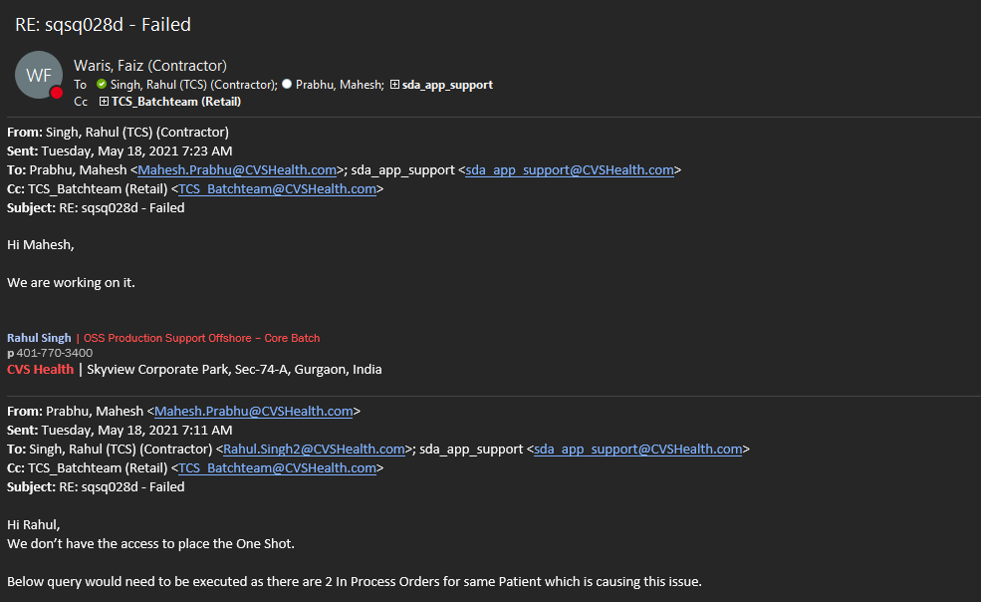
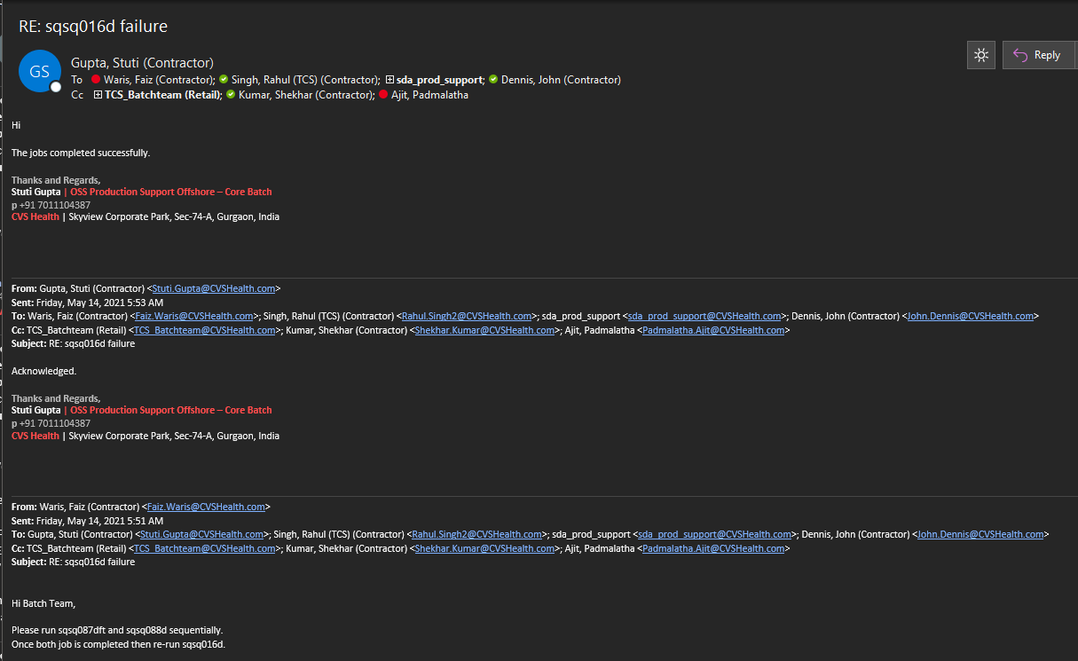
As such, IA concludes that Job failures were addressed according to standards. No action items or expectations were noted.

Conclusion

Control appear to be operating effectively.

